LAB 6: TO IMPLEMENT A.L.U. DESIGN

Name: Shreyas Sawant Div: D7A Roll No.: 55

Arithmetci Logic Unit (A.L.U.):

AND OPERATOR

S1=0 S0=0

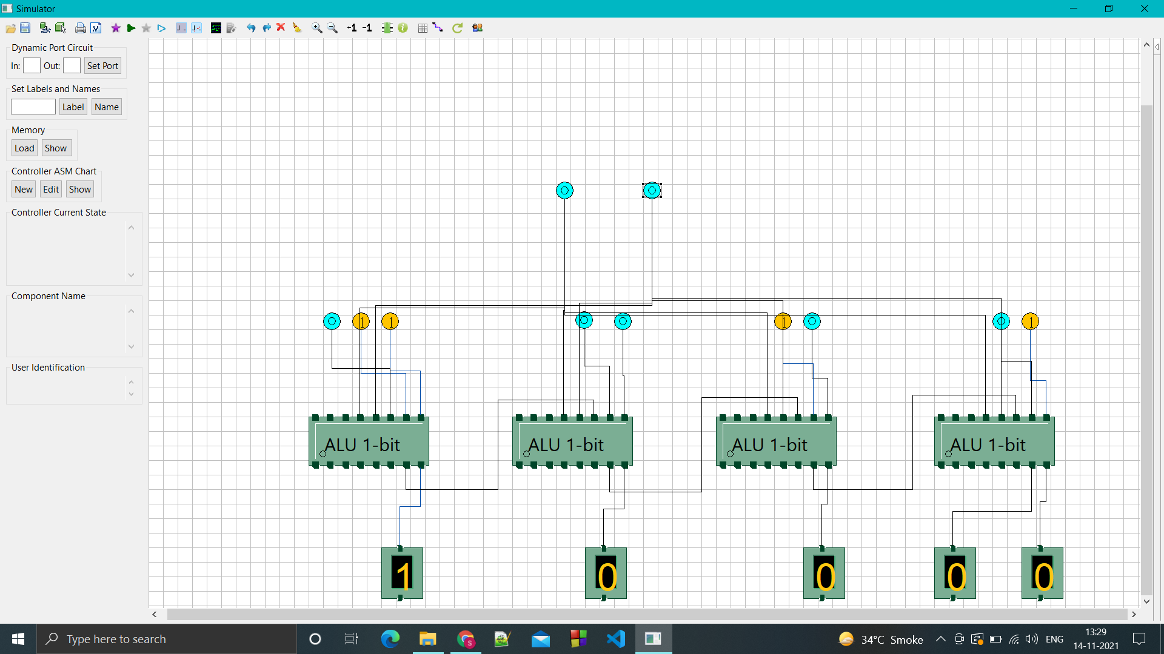

OR OPERATOR

S1=0 S0=1

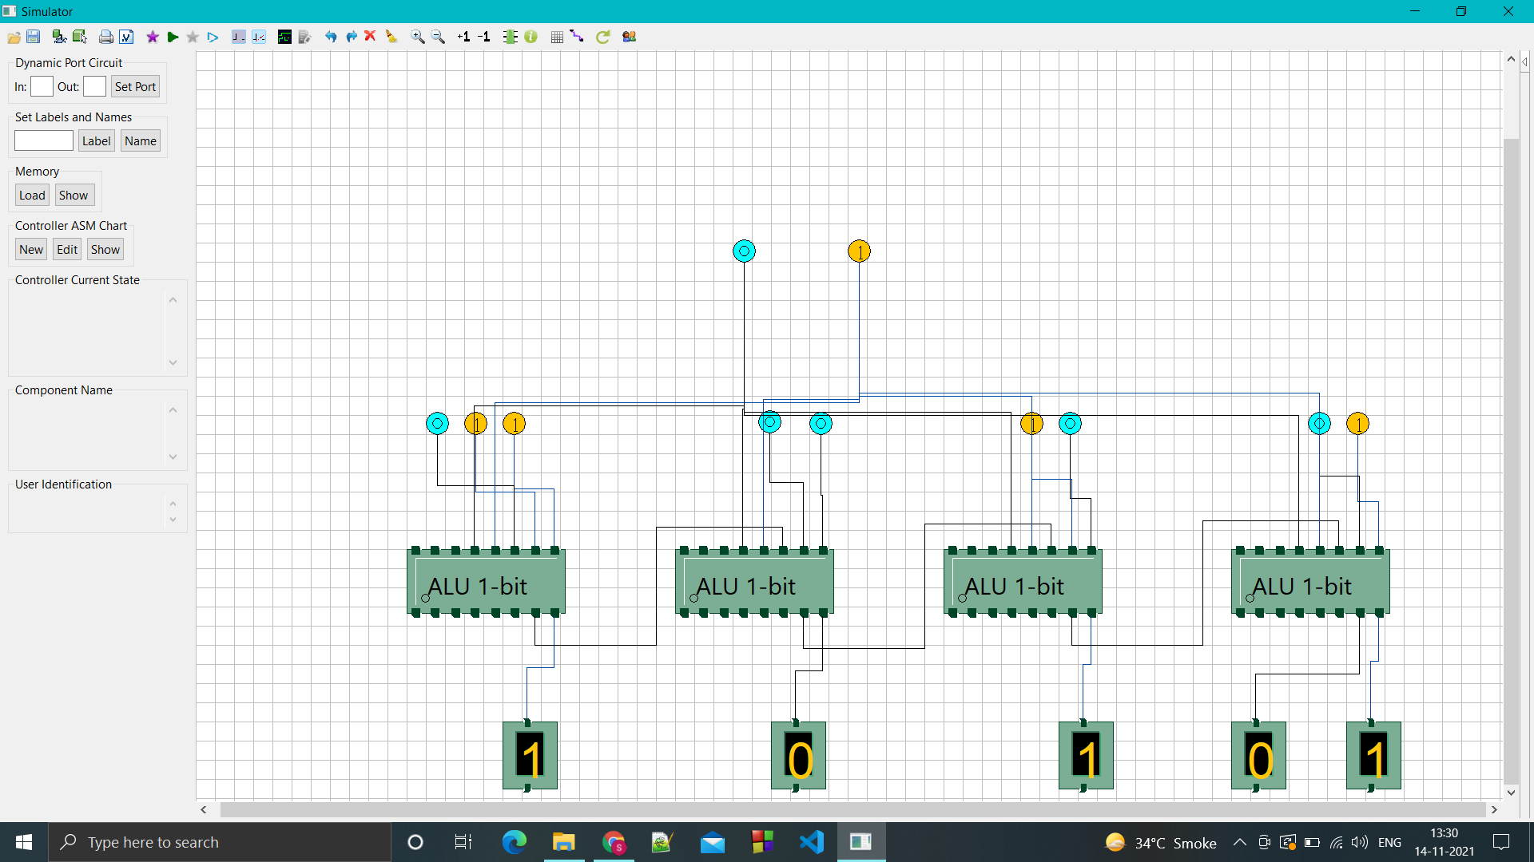

XOR OPERATOR

S1=1 S0=0

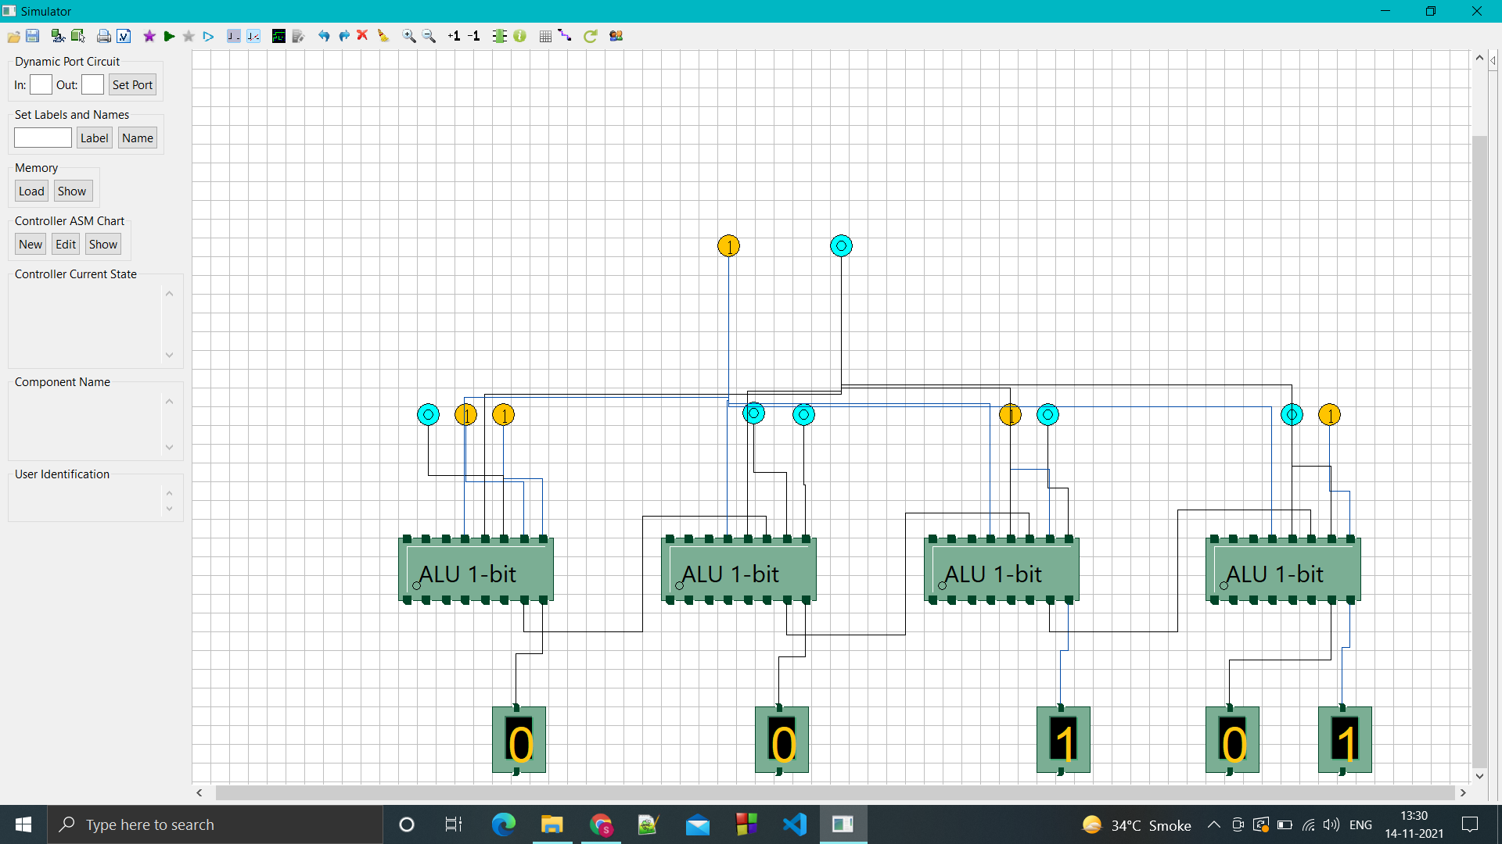

ADD OPERATOR

S1=1 S0=1

1001 + 0011 = 1110

